First we run Gparted on DRBL desktop
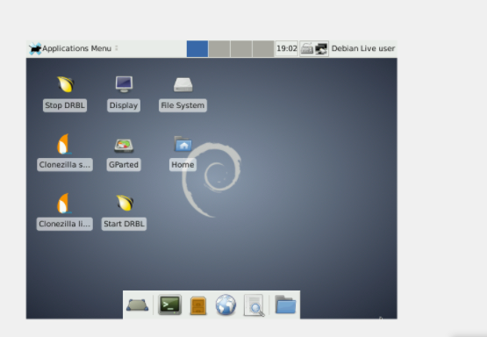
Let us create our partition table through the menu
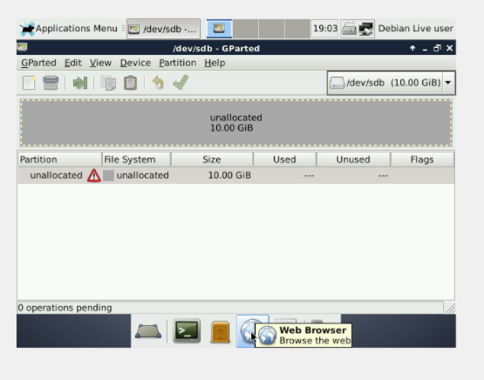

With right-button click on the unallocated space
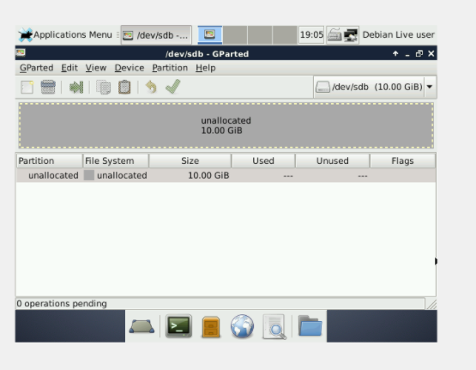
Then we are going to create a Primary Partition of 2GB, whose file system is NTFS and its name PNTFS.
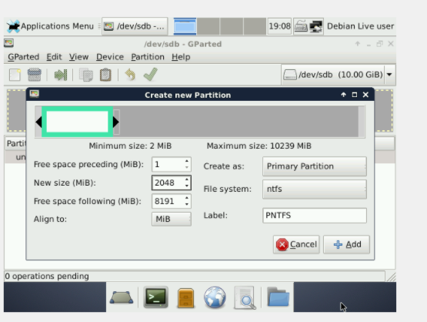
We are going to create another primary partition of 2GB, file system EXT4 and label PEXT4.
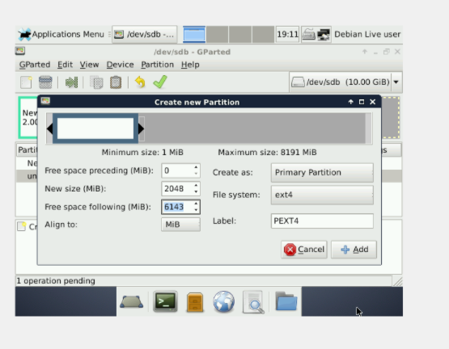

Now, we do the same process to create an extended partition using all the available space. we will put PEXTENDED as a label.
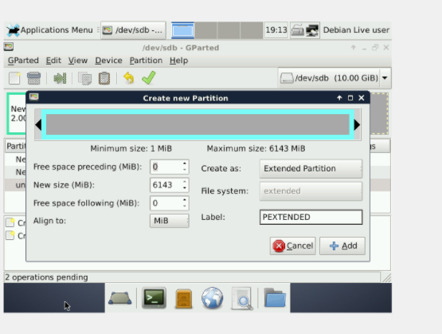

Next, we right click on the extended partition and we will create a 2GB logical drive, which has 2GB, FAT32 file system and PFAT32 label.
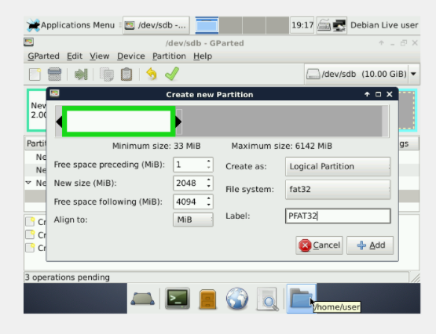

As a final result, we will have 2 GB of unallocated space both on the extended partition and on the rest of the disk.
